UNIT 3
INSTRUCTION FORMAT
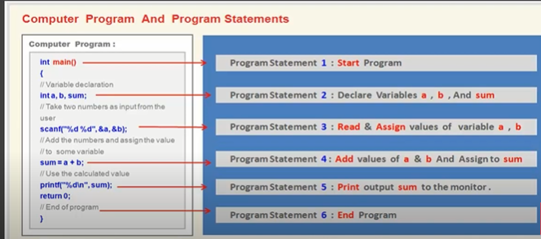

3.1 Introduction to Instruction format
In computer architecture, the instruction format is defined as standard machine instruction format that can have directly decoded (translated) and executed by the central processing unit (CPU). The instruction format is simply a sequence of bits (0, 1) contained in a machine instruction that defines the layout of the instruction. The machine instruction contains number of bits (pattern of 0 and 1). These bits are grouped together called fields. Each field of the machine instruction provides specific information to the CPU regarding the operation to be performed and the location of the data.
An instruction format is also defined as layout or pattern of bits in the machine instruction that directs the CPU to decode and execute the instruction.
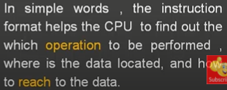
Operand
In computer, an operand is a term used to describe any object that is capable of being manipulated. For example, in "1 + 2" the "1" and "2" are the operands and the plus symbol is the operator.
What is instruction format?
The instruction format defines the layout of the instruction in terms of group of bits called fields of the instruction format. Each field (group of bits) in the instruction format provide a specific information to the processor. The processor needs to know the information regarding the operation to be performed and the location of the data (address).
INSTRUCTION FORMAT:
15 12 11 0
OPCODE | OPERAND (ADDRESS OF DATA)
4 12
In instruction format, the bits are grouped together in three parts. They are:
- Addressing mode (MODE)
- Operation code (OPCODE)
- Address of the Data (OPEREND)
Here,
MODE:- It specifies the addressing mode i.e. direct or indirect.
OPCODE:- name of operation like add, sub, mul, div, etc.
ADDRESS (OPERAND): tells the address of operand on which the operation is performed. E.g. A, B, C, R1, R2 etc.
In 16 bit format, 12 bits is for address part and 4 bits is for OPCODE.
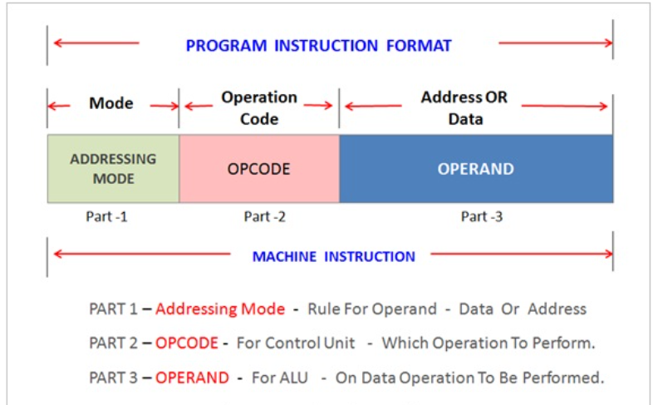

Figure: instruction format

We will learn three method (types) to fetch the operand
- Immediate operand
- Direct addressing
- Indirect addressing
Immediate operand: In immediate operand (address) the actual operand values is available. Operand is directly provided as constant.
Instruction format:
15 12 11 0
OPCODE | OPERAND

E.g. LOAD Ri, #100
# represent that the following value is of operand that is to be loaded in the given register,
Here, Ri is register location. Immediate operand is faster than other addressing.
Here: 100 will be loading in Ri register.
Ri
100

Example 2:
ADD R_{i}, #3
Here 3 will be add with the value of R_{i} in R_{i} register.
R_{i} =R_{i}+3
Advantage:
- Fastest execution of the instruction
- Operand access time is constant
Disadvantage:
- Very less flexibility.
Direct addressing:
Direct address specifies address of operand. Actual address is given in instruction. It is use to access variables.
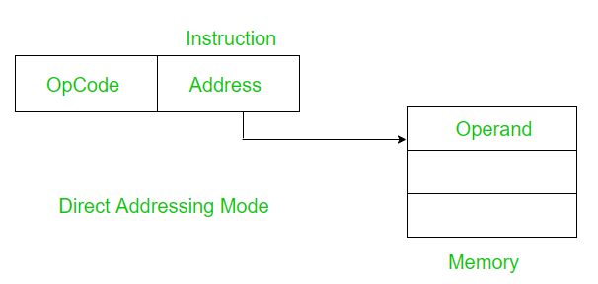
e.g. LOAD Ri, 1000
Now, instruction will go memory location 1000 and fetch the operand.
20
1000 Ri
We can say, the operand to be loaded in Ri is presented at memory location 1000.
e.g. 2
ADD Ri, 400
We can say, the operand to be loaded in Ri is presented at memory location 400.
Now, it will fetch the value of operand from location 400.
Ri Ri + value
Indirect addressing:
This is the mode of addressing where the instruction contains the address of the location where the target address is stored. So in this way it is indirectly storing the address of the target location in another memory location. So it is called Indirect Addressing mode.
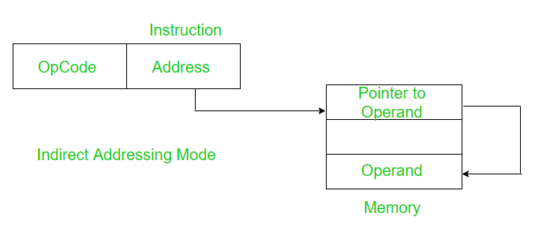
There are four types of instruction format. They are:
- Three address instruction
- Two address instruction
- One address instruction
- Zero address instruction
Three address instruction
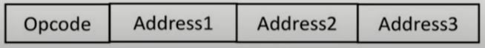
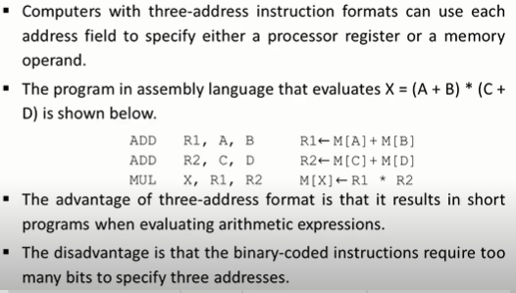
Two address instruction
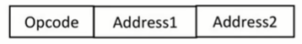
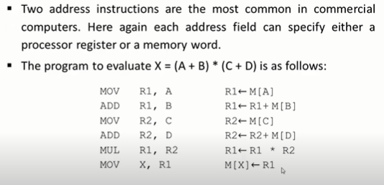
One address instruction

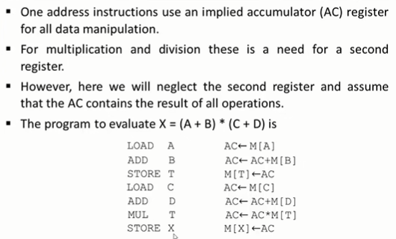

Zero address instruction

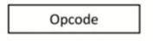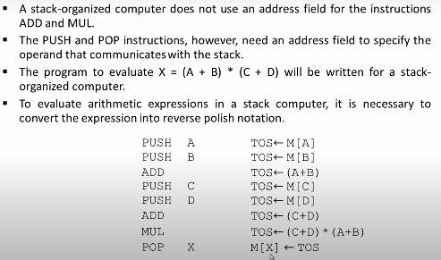

Instruction type
There are three instruction types. They are:
- Memory reference instruction
- Register reference instruction
- Input and output instruction
Memory reference instruction:
These instructions refer to memory address as an operand. That means these instruction are going to deal with the memory operands. The operand provided to this instruction would be fetched from the memory and would be stored in accumulator and would be processed so these are memory reference instruction. The instruction format specifies 12-bit address, 3-bit opcode (other than 111) and 1 mode-bit addressing for direct and indirect addressing.
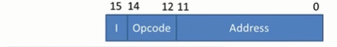
The opcode and addressing mode that is direct or indirect would be changing in memory reference instruction.
For 0 000,
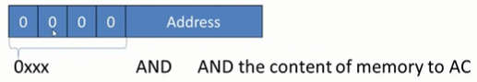
For 0 001,

1xxx ADD ADD the content of memory to AC.
For 0 010,
2xxx LDA load memory word to AC,
Similarly, here is the whole table for memory addressing Reference.
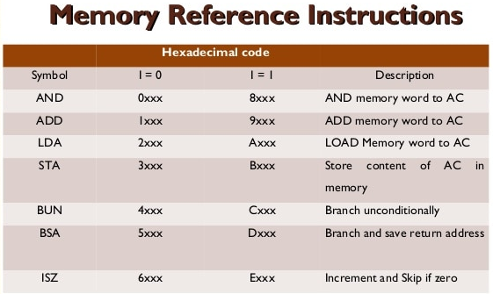
Register Reference Instruction
Register Reference Instruction mean it will perform certain operation on to the register. The register operation would be decided based on 0-11 bits, so total of 12 bits will decide what register operation we want to perform. But 4 bits from 12 to 15 that is 111 and 0 fix for will remain this register reference instruction. The change would be there in register operation that is 0 to 11 bits and they will decide which operation will be performed.
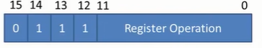
Fig: register reference instruction format.
For 0111 1000 0000 0000
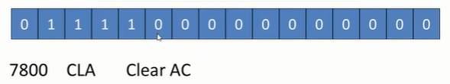
For 0111 0100 0000 000
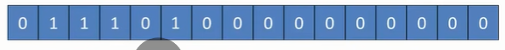

Similarly here is whole register reference instruction table.
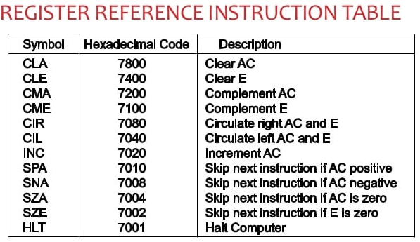
Input and output instruction
It perform the instruction on to input and output devices. These instructions are for communication between computer and outside environment. The IR(14 – 12) is 111 (differentiates it from memory reference) and IR(15) is 1 (differentiates it from register reference instructions). The rest 12 bits specify I/O operation. 12-15 bits remains same in I/O instruction i.e. 1111.
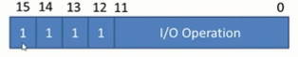
Fig: I/O instruction format
For 1111 1000 0000 0000
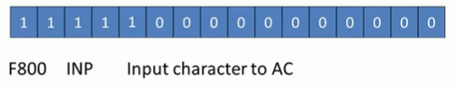
For 1111 0100 0000 0000

Similarly here is whole I/O instruction table.
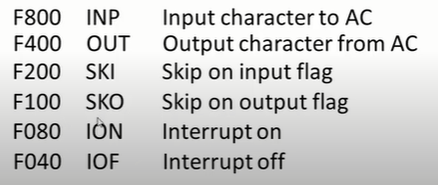

3.3 Instruction Set Completeness
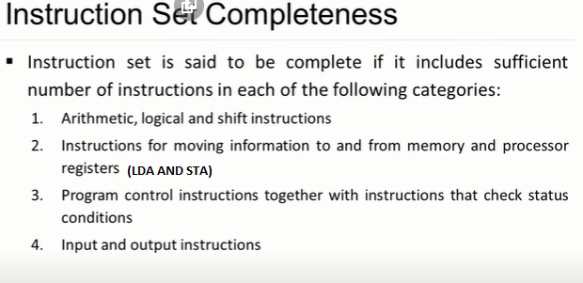
In instruction set completeness, Arithmetic, logical, and shift instructions provide computational capabilities for processing the type of data that the user may wish to employ. The bulk of the binary information in a digital computer is stored in memory, but all computations are done in processor registers. Decision making capabilities are an important aspect of digital computers. Program control instructions such as branch instructions are used to change the sequence in which the program is executed. Input and output instructions are needed for communication between the computer and the user. Programs and data must be transferred into memory and results of computations must be transferred back to the user.
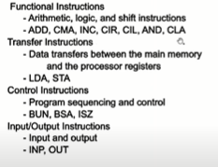

3.5 Instruction Cycle
A program consisting of the memory unit of the computer includes a series of instructions. The program is implemented on the computer by going through a cycle for each instruction.
In the basic computer, each instruction cycle includes the following procedures −
- It can fetch instruction from memory.
- It is used to decode the instruction.
- It can read the effective address from memory if the instruction has an indirect address.
- It can execute the instruction.
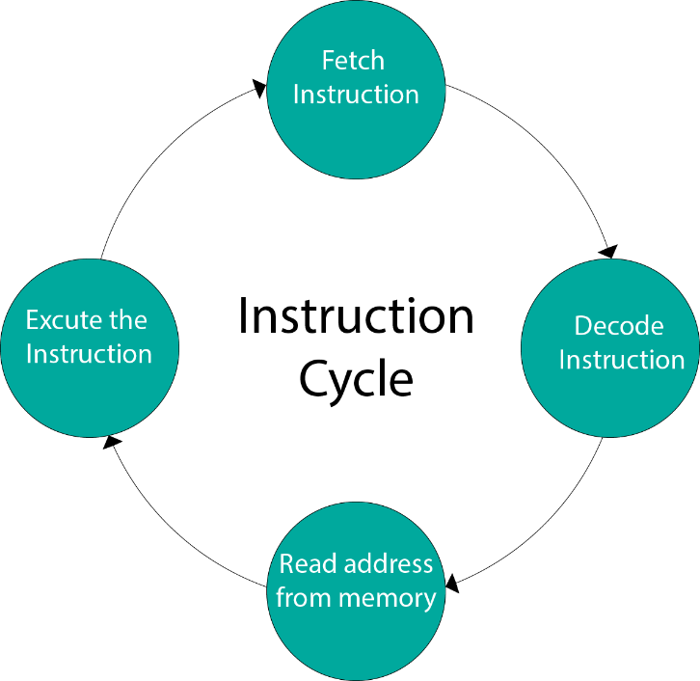
FIG: instruction cycle
After the following four procedures are done, the control switches back to the first step and repeats the similar process for the next instruction. Therefore, the cycle continues until a Halt condition is met. The figure shows the phases contained in the instruction cycle.
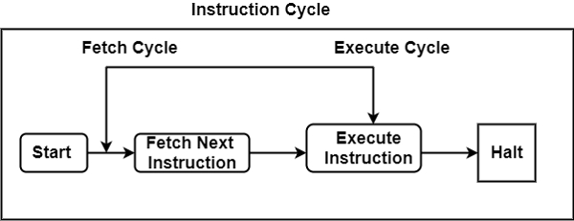
As display in the figure, the halt condition appears when the device receive turned off, on the circumstance of unrecoverable errors, etc.
Fetch Instruction
The processor fetches the instruction from the memory that is pointed by the PC. Next, the PC is incremented to display the address of the next instruction. This instruction is loaded onto the instruction register. The processor reads the instruction and executes the important procedures.
Execute Cycle
The data transfer for implementation takes place in two methods are as follows −
- Processor-memory −The data sent from the processor to memory or from memory to processor.
- Processor-Input/Output −The data can be transferred to or from a peripheral device by the transfer between a processor and an I/O device.
In the execute cycle, the processor implements the important operations on the information, and consistently the control calls for the modification in the sequence of data implementation. These two methods associate and complete the execute cycle.

